# International Yoga Day 2023

**Date:** 21 June 2023

**Time:**  9:30 AM

**Objective:** For the betterment of student’s overall skill development.

**Brief:** 9th International Yoga Daywascelebrated by the students, teachingand Non- Teaching of PDEA College of Architecture, Akurdi. On 21st June 2023 with great enthusiasm. All staff also Participated in the celebration.

The function began with a brief introduction of yoga day by Academic coordinator Prof. Swati Rode a brief introduction of yoga expert our 2nd Year Student Sahil Gund. He explained that regular practice of yoga will help the students achieve better mental and physical health. After which few warm up and simple asanas. they also performed standing and sitting asanas. The function ended with a vote of thanks by Prof. Swati Rode.

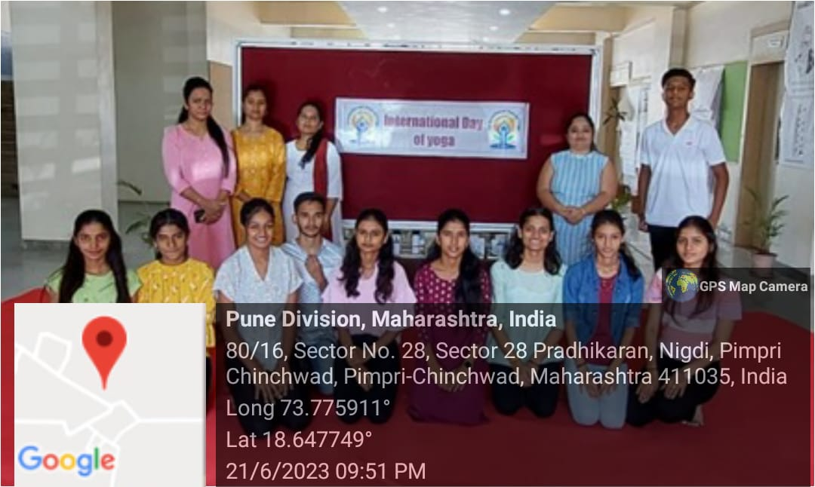

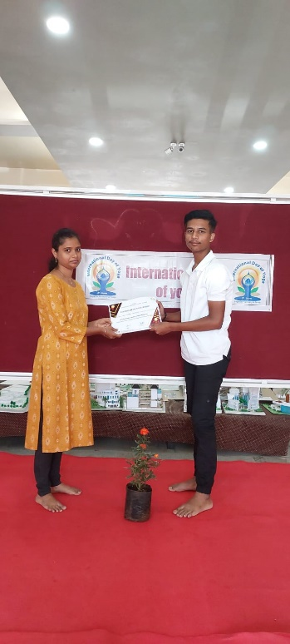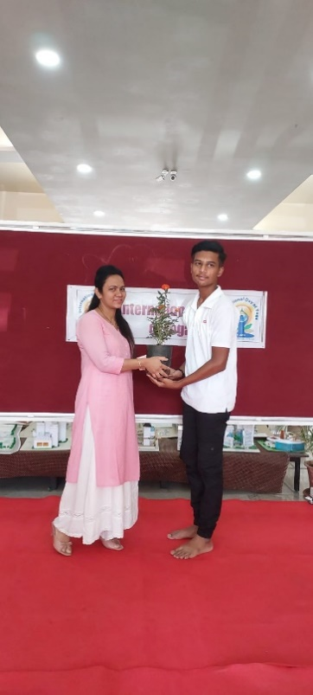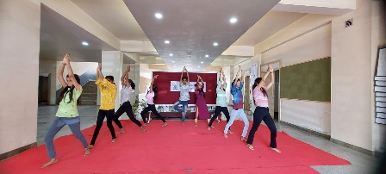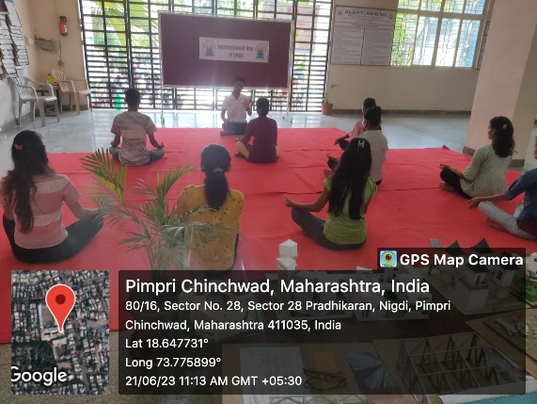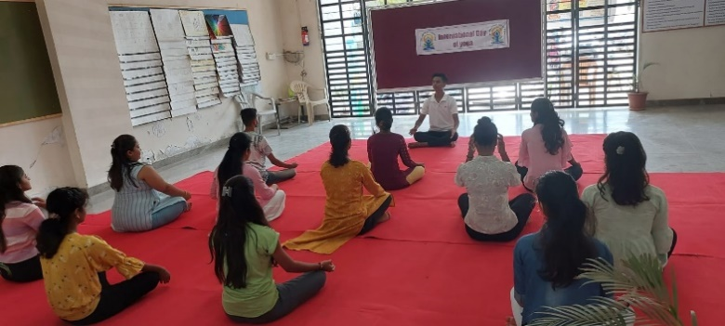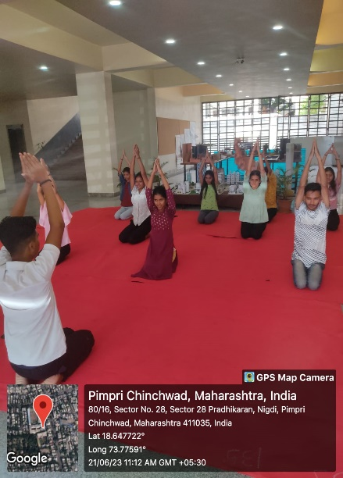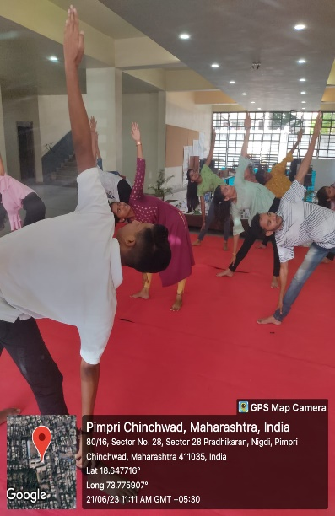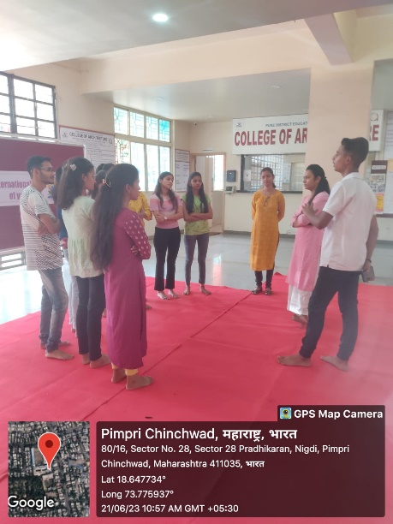

**OUTCOME**

1. Celebration of 9th International Yoga Day: The report highlights the successful celebration of the 9th International Yoga Day by the students, teaching, and non-teaching staff of PDEA College of Architecture, Akurdi, on 21st June 2023, with great enthusiasm.
2. Participation: All staff members actively participated in the celebration, indicating a collective interest and commitment to promoting yoga and its benefits.
3. Introduction and Explanation: The function commenced with a brief introduction of Yoga Day by the Academic Coordinator, Prof. Swati Rode. Subsequently, a 2nd-year student, Sahil Gund, who is a yoga expert, provided insights into the importance of regular yoga practice for enhancing mental and physical health among students.
4. Yoga Sessions: Various yoga sessions were conducted during the event, including warm-up exercises and simple asanas. Both standing and sitting asanas were performed, catering to the diverse needs and preferences of the participants.
5. Academic Involvement: The involvement of Prof. Swati Rode and the participation of students like Sahil Gund showcase the integration of yoga-related activities into the academic curriculum, emphasizing holistic development beyond traditional classroom learning.
6. Conclusion: The report concludes with a vote of thanks by Prof. Swati Rode, acknowledging everyone's participation and contributions to making the event a success.

Overall, the outcome of the report reflects a positive and proactive approach towards promoting yoga as a means to foster physical well-being, mental clarity, and overall holistic development within the academic community of PDEA College of Architecture, Akurdi.